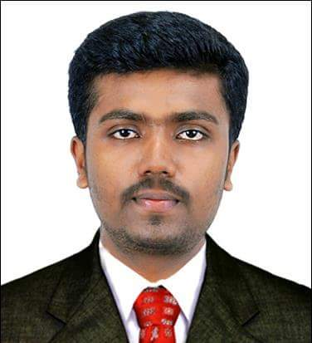

**DEEPAK DS**

***Personal Details***

**CURRICULUM VITAE DEEPAK D S**

***Date of Birth*** **:** **24th February 1994**

***Nationality*** **:** **INDIAN**

***Marital Status*** **:** Single

***Father’s Name* :** C.Durairaj

***Permanent Address*** **:** Salemil(H),

Athirampuzha P.O,

Kottayam Dt Kerala,

India - 686562

***E - Mail*** **:** [dpk775@gmail.com](mailto:dpk775@gmail.com)

***Contact (Mob)* :** **7012671689,7736505039**

***Languages Known* :** English, Malayalam & Tamil

##### *Career Objective*

To secure a responsible position in the automotive industry where I can develop new skills while adding profit to the company.

|  |  |  |  |
| --- | --- | --- | --- |
| Qualification | Board / Institute | Year of Completion | Aggregate % |
| Diploma in  Manufacturing Technology | **KELTRAC (Keltron Tool Room Research and Training Centre), Aroor** | **2017** | **60%** |
| HSE | **St. Ephermes HSS, Mannanam** | **2013** | **58%** |
| SSLC | **St. Aloysius HSS, Athirampuzha** | **SSLC** | **67%** |

##### *Educational Profile*

##### *Key Skills*

* Passionate about learning and understanding technical facts about all kinds of vehicles.
* Ability to troubleshoot, test, repair and service technical equipment.
* Punctual.
* Ability to work flexible shifts and to adapt to changing work schedules.
* Communication Skills.
* Familiarity withtools and applications.
* Passionate about learning new things.

##### *Qualifications*

* Completed 3-year Diploma in **‘Manufacturing Technology’**. Well-experienced in AutoCAD.
* Six years of driving experience.

**CURRICULUM VITAE DEEPAK D.S**

##### *Technical Skills*

Declaration:

I hereby declare that all the above-mentioned information is correct and true to the

best of my knowledge.

* Honed ability to identify and resolve basic maintenance problems.
* AUTOCAD Designing
* LMV, HMV Driving Skills.
* CNC (Programing, LATHE, Milling)

##### *Academic Project*

* As a fulfilment of our academic requirements, we designed and fabricated a CNC Plotter machine

as a group project.

##### *Hobbies & Interests*

* Driving
* Travelling
* Badminton
* Cycling
* Football
* Cricket

##### *Declaration*

I hereby declare that all the above-mentioned information aretrue and correct to the best of my knowledge and belief.

Kottayam Deepak D.S

25/09/2020